Anabela Petrushevikj
D212 PA Task 1
July 30, 2025
Professor Kamara

Part I: Research Question
A.
A1. How can k-means clustering techniques uncover patterns among patients who are readmitted to the hospital based on their health and hospitalization data?

A2. The goal of this data analysis is to identify distinct groups of patients who were readmitted to the hospital, based on patterns in their health status and hospitalization data, using k-means clustering. By uncovering these subgroups, the analysis aims to provide insight into which types of patients are more likely to be readmitted and what characteristics they have in common. This goal is appropriate for the selected scenario, which focuses on understanding and addressing patient readmissions, a key concern for hospitals under CMS guidelines. The available dataset includes relevant continuous variables such as initial days hospitalized, number of doctor visits, age, overweight status, and readmission history, making this analysis both practical and data-supported. The insights gained can help stakeholders develop more targeted intervention strategies, improve care coordination, and potentially reduce costly and preventable readmissions.
Part II: Technique Justification
B.
B1. K-means clustering is a commonly used unsupervised learning method that groups similar records based on shared characteristics. In this case, it is applied to continuous patient data such as age, length of stay, doctor visits, overweight status, and readmission history to uncover patterns among those who were readmitted to the hospital. The technique begins by selecting a set number of cluster centers, known as centroids. Each patient is then assigned to the nearest centroid based on the similarity of their data. The algorithm continues to refine the position of these centroids, recalculating and reassigning them until the groupings are as tight and distinct as possible. The expected outcome is to uncover clear, meaningful clusters of patients who exhibit similar health profiles or hospitalization experiences. For example, a group might emerge with higher doctor visit counts and longer hospital stays, or another where younger patients with fewer visits still experience readmission. These insights can help hospitals better understand the types of patients who are at higher risk of returning, ultimately guiding more personalized care planning and resource allocation. (IBM, 2020; Pedregosa et al., 2011)

B2. One key assumption of k-means clustering is that clusters are spherical and evenly sized, meaning the algorithm works best when the groups in the data are relatively similar in size and shape. This assumption is important because the algorithm uses distance to determine membership, and uneven or non-globular groupings can affect accuracy. (IBM, 2020)

B3. For this analysis, several Python libraries were used to manage, process, and analyze the data effectively:
- pandas: This library was used for loading and handling the dataset. It makes it easy to select relevant columns, clean the data, and organize it for analysis.
- numpy: Numpy provides support for numerical operations and array structures, which are essential when performing mathematical transformations and clustering calculations.
- matplotlib.pyplot and seaborn: These two libraries were used for data visualization. They helped plot the Elbow curve and Silhouette scores to determine the optimal number of clusters and visualize the final clusters using PCA. Seaborn also provided aesthetic improvements for clearer, more readable plots.
- scipy.stats.zscore: The zscore function was used to detect outliers by measuring how far each data point deviates from the mean in terms of standard deviations. This helped ensure that extreme values did not distort the clustering results.
- sklearn.preprocessing (StandardScaler, LabelEncoder): These tools prepared the data for clustering. StandardScaler was used to normalize the numerical variables so that each feature contributed equally to the clustering process. LabelEncoder was used to convert categorical variables into numerical form where needed.
- sklearn.cluster.KMeans: This is the core library used to implement the K-means clustering algorithm. It performed the task of grouping patients based on similarities in their health and hospitalization patterns.
- sklearn.metrics.silhouette_score: This metric was used to evaluate the quality of the clusters. It helped identify the number of clusters that created the most distinct and well-separated groups.
- sklearn.decomposition.PCA: Principal Component Analysis (PCA) reduced the high-dimensional dataset into two principal components. This allowed for a visual representation of clusters in a two-dimensional plot, making it easier to interpret the groupings.
Each of these libraries plays a key role in ensuring the data is properly prepared, analyzed, and visualized in a way that supports meaningful insights from the clustering process.
Part III: Data Preparation
C.
C1. One key data preprocessing goal for this project was to ensure that all features used in clustering were on the same scale. Since K-means clustering relies on distance calculations between data points, unscaled features can distort the clustering results. Therefore, standardizing the continuous variables using a feature scaler was essential to allow each variable to contribute equally to the formation of clusters. (Pedregosa et al., 2011; Wongoutong, 2024)

C2. The variables selected for this clustering analysis were chosen based on their relevance to hospitalization and potential influence on readmission patterns. The data types are as follows:
- Initial_days – Continuous
- Doc_visits – Continuous
- Age – Continuous
- ReAdmis – Categorical (Yes/No, later encoded)
- Overweight – Categorical (Yes/No, later encoded)
C3. Before performing the K-means clustering analysis, the dataset needed to be carefully prepared to ensure compatibility with the algorithm. One of the main preprocessing goals was to standardize the scale of all variables. Since K-means relies on Euclidean distance to group similar observations, variables like "Initial_days" and "Age" must be normalized to prevent any single feature from disproportionately influencing the clustering process.
Firstly, five relevant variables were selected from the dataset: Initial_days, Doc_visits, and Age were identified as continuous variables, while ReAdmis and Overweight were categorical and later converted to a numeric format.
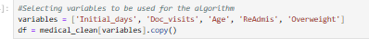
The dataset was then checked for duplicate entries using df.duplicated().sum(), and while none were found, this step ensured data integrity.
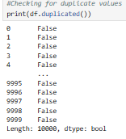
Similarly, a check for missing values confirmed that all rows were complete, avoiding the need for imputation.
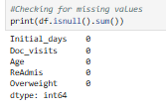
Next, outlier detection was performed to assess whether extreme values might distort the clustering outcome. The Z-score method was used on the numerical columns ('Initial_days', 'Doc_visits', and 'Age') to identify data points exceeding 3 standard deviations from the mean. This revealed that there were 8 outliers in the 'Doc_visits' column and none in the others. A boxplot was also generated to visually confirm this finding; however, the outliers in 'Doc_visits' were not clearly visible in the boxplot, likely due to their proximity to the whiskers. Since the outliers were few and did not show a strong visual deviation, they were retained in the dataset.
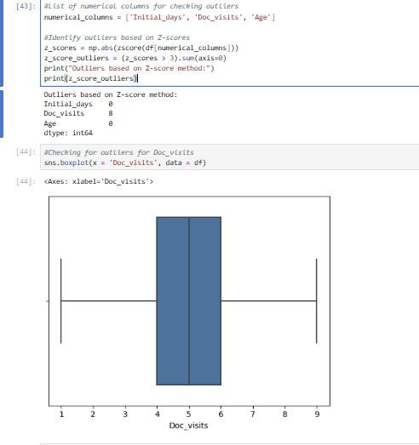
To convert the categorical values into numeric form, ReAdmis and Overweight were mapped to binary values (Yes = 1, No = 0), which allowed the algorithm to process them as part of the distance-based clustering.
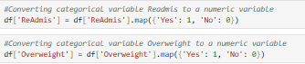
Once the data was cleaned and numerically encoded, feature scaling was performed using StandardScaler() from the sklearn.preprocessing library. This transformation centered the data around a mean of zero and scaled it to unit variance, a critical step for the effectiveness of K-means clustering.
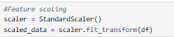
At this point, the data was ready for clustering, with all features properly formatted and on a uniform scale.

C4. A copy of the cleaned data has been attached.
Part IV: Analysis
D.
D1. To identify the optimal number of clusters for this analysis, two well-established methods were applied: the Elbow Method and the Silhouette Score. The Elbow Method involved plotting the inertia values for a range of cluster counts from 2 to 9. As the number of clusters increases, the inertia naturally decreases. However, the point at which the rate of decrease slows significantly, forming an "elbow" in the curve, indicates a suitable number of clusters. In this analysis, the elbow appeared at k = 3, suggesting that three clusters provide a balanced and meaningful segmentation of the data. To validate this result, the Silhouette Score was also evaluated for each k value. This metric measures how well-separated the clusters are, with higher scores indicating better defined groupings. The silhouette plot confirmed that k = 3 yields the highest score, reinforcing the choice made using the Elbow Method. Together, these two methods provided strong, complementary evidence that three clusters offer the most appropriate structure for the data, enabling meaningful interpretation of patterns among readmitted patients.

D2. Code:
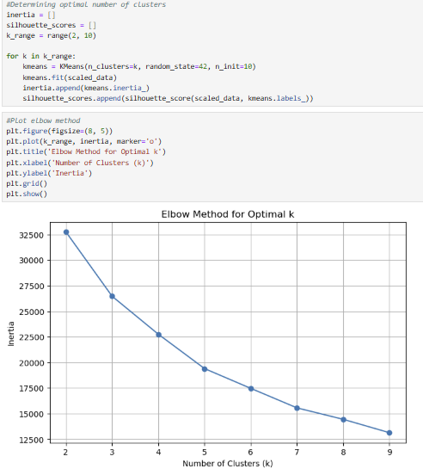
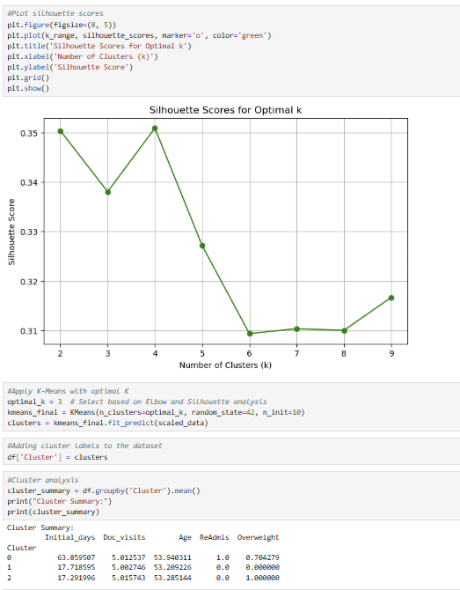
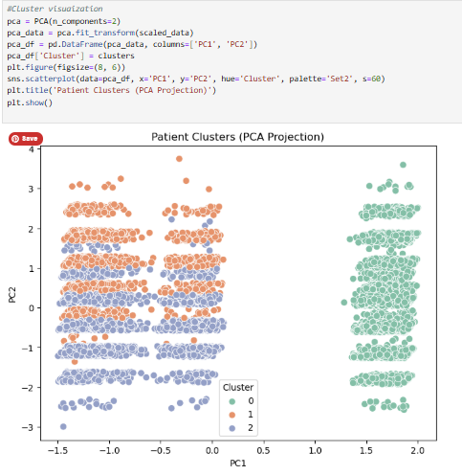
Part V: Data Summary and Implications
E.
E1. The quality of the clusters was assessed using both the Silhouette Score and PCA visualization. The average Silhouette Score reached its highest value at k = 3, with a score of approximately 0.35, indicating moderately well-defined clusters. While Silhouette Scores closer to 1.0 reflect highly distinct groupings, scores in the 0.3–0.4 range are considered acceptable in real-world healthcare datasets where some feature overlap is expected due to the complexity of patient profiles. The PCA projection (refer to the third screenshot) visually reinforces this evaluation. Cluster 0 appears separated from Clusters 1 and 2 along the first principal component (PC1), suggesting a distinct subpopulation of patients with unique characteristics such as significantly higher initial hospital stay duration and readmission rate. While Clusters 1 and 2 exhibit partial overlap, they still show internal consistency, especially when considering binary features like Overweight and ReAdmis. Together, the combination of moderate Silhouette validation and visual clustering structure indicates that the model produced meaningful and interpretable segments. These clusters offer actionable insights into patient readmission patterns and support the overall quality of the analysis. (Pedregosa et al., 2011; Wongoutong, 2024)

E2. The clustering analysis revealed three distinct patient groups based on health and hospitalization patterns. Each cluster displayed unique characteristics, allowing for a clearer understanding of how different combinations of clinical factors are associated with hospital readmissions. Cluster 0 emerged as the highest-risk group. Patients in this segment had significantly longer hospital stays (average Initial_days = 63.86), a readmission rate of 100% (ReAdmis = 1.0), and a high proportion of overweight individuals (Overweight = 0.70). These patterns suggest that patients in Cluster 0 experience more complex or severe conditions that may require targeted interventions, closer follow-up, or more intensive care coordination. Cluster 1 and Cluster 2, while somewhat overlapping in the PCA projection, still show meaningful differences. Cluster 1 includes patients who are not overweight (Overweight = 0.0), while Cluster 2 consists entirely of overweight patients (Overweight = 1.0). Both groups share a moderate number of doctor visits (around 5 visits on average) and similar ages, but they differ in readmission rates and hospital stay durations. These variations may reflect lifestyle or chronic condition differences that could be addressed with customized education, preventive care, or monitoring. The implications of these findings are important for hospital management and patient care planning. By identifying shared patterns among patients who are frequently readmitted, healthcare providers can design more personalized and proactive care strategies. For example, interventions such as post-discharge support programs, weight management resources, or extended case management services may be prioritized for patients falling into high-risk clusters. Overall, the analysis supports the use of clustering as a practical tool to segment patient populations and enhance targeted healthcare delivery.

E3. A limitation of this analysis is that K-means clustering assumes that all clusters are spherical and equally sized, which does not reflect the true structure of most real-world medical data. In this project, that limitation was evident in the overlap between Clusters 1 and 2, as seen in the PCA visualization. Despite standardizing the data and using Silhouette Scores to guide cluster selection, the algorithm still formed clusters that were not separated, an indication that the underlying patient groups may not fit the geometric constraints of K-means. This structural assumption can lead to misleading groupings when patient data is unevenly distributed or shaped by complex relationships, which is often the case in healthcare. As a result, while K-means provided a helpful starting point, it may not fully capture the nuances needed for more accurate patient segmentation and risk profiling. (IBM, 2020)

E4. Based on the clustering results, the hospital should implement tiered post-discharge care plans tailored to patient groups with similar health and hospitalization profiles. The analysis revealed that patients in Cluster 0, characterized by longer initial hospital stays, more frequent doctor visits, and a higher likelihood of readmission, may require more intensive post-discharge support. For this group, the organization should consider assigning care coordinators, scheduling earlier follow-up appointments, and providing ongoing monitoring to reduce the risk of readmission. Patients in Clusters 1 and 2, who generally had shorter hospital stays, fewer doctor visits, and lower readmission rates, could follow standard discharge protocols with periodic follow-up. However, targeted education around preventive care and healthy weight management may still be beneficial, particularly for those flagged as overweight. By leveraging these cluster-based insights, the organization can take a more proactive and personalized approach to discharge planning, improving outcomes for high-risk patients while optimizing resources used across the broader patient population.
Part VI: Demonstration
F. Panopto video has been attached.
G. Wilson, B., Daltyorl, S., Boeye, J., & Hull, I. (2025). Data Mining II. Data Camp. https://app.datacamp.com/learn/custom-tracks/custom-data-mining-ii
H. Sources:
Pedregosa, F., Varoquaux, G., Gramfort, A., Michel, V., Thirion, B., Grisel, O., ... & Duchesnay, É. (2011). Scikit-learn: Machine learning in Python. Journal of Machine Learning Research, 12, 2825–2830.
https://www.jmlr.org/papers/v12/pedregosa11a.html
IBM. (2020). K-means clustering explained. IBM Developer.
https://developer.ibm.com/articles/learn-ds-k-means-clustering/
Wongoutong, C. (2024). The impact of neglecting feature scaling in k-means clustering. PLOS ONE, 19(12), e0310839. https://doi.org/10.1371/journal.pone.0310839

